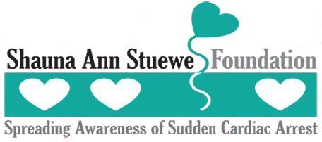
Bowl For A Cause!
Linbrook Bowling Center
Sunday, May 17th, 2009
Join us on Sunday, May 17th at 1:00pm for a Bowl-A-Thon at 201 S. Brookhurst St., Anaheim, CA 92804 at Linbrook Bowling Center to raise funds to Spread Awareness of Sudden Cardiac Arrest, help schools implement Automated External Defibrillator (AED) programs and to help purchase AED's.
All bowlers need a registration form. Registration is $25 and includes 2 games of bowling, shoes, pizza and a soda. To make this fundraiser a huge success we need you to get sponsors! For every $20 in sponsorships, you will receive a raffle ticket. We will be raffling items off throughout the Bowl-A-Thon!
Please be at the bowling center at 12:30 for registration and lane assignment.
Please Complete Form Below and Return with check payable to Shauna Ann Stuewe Foundation, P.O. Box 27246, Anaheim Hills, CA 92808, or give to one of the committee members by May 10th to reserve you spot!

Last Name ______________________________ First Name _______________________________

Mailing Address: ___________________________________________________________________

City: _________________________ State: _____________________ Zip: _____________________

Home Phone#: ________________________ Alternate Phone#: _____________________________

Email: ____________________________________________________________________________

Please check one:  I am bowling as an Individual
 I am bowling as a Team (please list team members below)
Team Members
1)
2)
3)
4)
5)

Waiver: I hereby waive all claims against Shauna Ann Stuewe Foundation, Linbrook Bowling Center and all sponsors, supporters, personnel and affiliates for any injury I might suffer at the Bowl-A-Thon event. I grant full permission for the organizer to use photographs of me in legitimate account and promotions of this event.

Signature: _______________________________ Parent/Guardian: __________________________________

