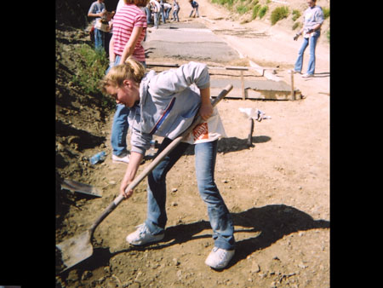
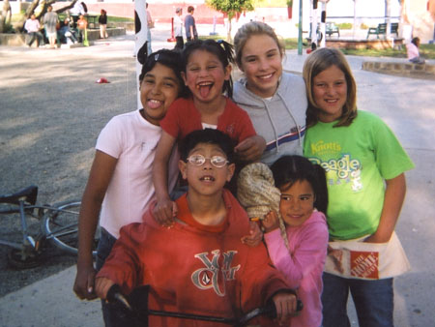

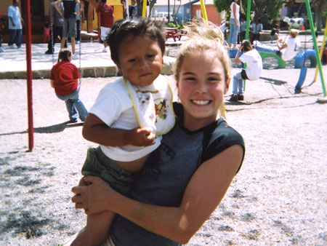
We are planning on taking a mission trip to the Door of Faith Orphanage in Mexico on Sunday, February 15th. We think this is a great way to honor Shauna on her “Heavenly Birthday.” Shauna went on her 1st Door of Faith Mission Trip in 2005 with her cousins and their church group. She was getting excited about going again in March 2006. She enjoyed helping with the building project but she was especially drawn to the kids and loved playing with them. It was a life changing experience!

We would love to have others join us. We will be buying pizza for all the kids and then we will spend time loving on them and end the day up at the cross where Shauna spent a lot of special time with God when she was there.

If you are not able to come but would like to help, you can make a donation to the SAS Foundation, in the memo put Door of Faith, and mail to P.O. Box 27246, Anaheim Hills, CA 92808. We will use the donation to purchase items for the kids. If you would like to purchase items yourself ….. Click on the following link for a list of things they need. http://www.dofo.org/ongoingneeds.php
You can drop them off at our house. (7609 E. Paseo Laredo, Anaheim Hills, CA 92808)

Please let us know by Tuesday, February 10th if you will be joining us so that we can make proper vehicle arrangements. (E-mail or you can call me @ (714) 609-3698.)

When: Sunday, February 15, 2009
Time: Leave early in the morning returning late evening(details to follow)
Cost: $25 - $35 depending on # of vehicles

What to bring: Passport or driver’s license (picture ID) and your birth certificate.

