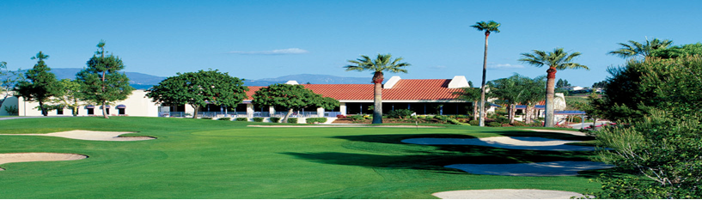
9th Annual “Golf for a Cause” Yorba Linda Country Club
June 26, 2017
bruary 29, 2016

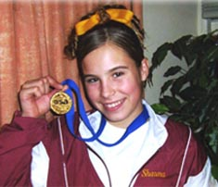

Shauna Stuewe
10/12/91-2/15/06

Thank you to our Loyal Sponsors:




Westwind FARMS

Real Estate Professional
www.CaseyBrookman.com

LAKEVIEW FARMS

T & W FARMS
Friends Church Yorba Linda, Westenbroek Family, LRES Corp. HUGEs Bros., Hathaway Dinwiddie, Nolan’s Equipment Rental
Platinum Sponsorship $5,000.00
Includes: A foursome, (4) Golf Packages (Closest-to-the-Pin and Longest Drive contests plus two Mulligans), (10) Raffle tickets per golfer, name recognition at individual hole and tournament banner.

Gold Sponsorship $2,500.00
Includes: A foursome, (10) Raffle tickets per golfer, name recognition at individual hole and tournament banner.

Silver Sponsorship $1,000.00
Includes: A foursome, (5) Raffle tickets per golfer, and name recognition at individual hole and tournament banner.

Hole Sponsorship $ 500.00
Includes: Name recognition at individual hole and tournament banner.

Foursome $ 700.00
($600.00 if payment received by January 15, 2016)

Single Player $ 175.00
($150.00 if payment received by January 15, 2016)

Spouse & Family Banquet Dinner Only: $35.00 ea.
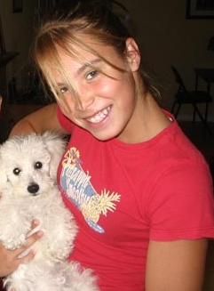
In Loving Memory of Shauna Stuewe
We are committed to the cause of raising public awareness about the risks of Sudden Cardiac Arrest (SCA) in our children.
Our mission is to promote pre-screening of our young athletes and to raise funds to provide Automated External Defibrillators (AED) in schools and other public locations promoting youth sports and athletic activities.

S
Golf for a Cause at Yorba Linda Country Club, 19400 Mountain View Ave. 10:00 a.m. Check-In, Putting Contest, Lunch 11:30 a.m. Shotgun Start Best Ball Scramble Format Dinner, Awards, Raffle & Silent Auction immediately following play

Shauna Stuewe
10/12/91-2/15/06
Registration Form due by June 25, 2017
Contact Name:
Contact E-mail:
Player Information:
Name:
1)
2)
3)
4)
Sponsorships:  - Platinum Sponsor $ 5,000.00  - Gold Sponsor $ 2,500.00  - Silver Sponsor $ 1,000.00  - Hole Sponsor $ 500.00  *Proper Golf Attire Required: No Denim* |  |  | - Foursome $ 700.00  - Foursome ** $ 600.00  - Single Player $ 175.00  - Single Player** $ 150.00  - Banquet Dinner Only $ 35.00  **Note: Payment must be received by 4/26/17 to be eligible for this discount price.
TOTAL DUE $_________

Credit Card Payment Information:
Name on Card:
Billing Address:
City, State, Zip:
E-mail/Phone#
CC #: |  |  |  | Security code:  (from back of card)
Expiration Date:
Signature:
Ways to pay:
- By Check: Mail this form along with your check (pay to “Shauna Ann
Stuewe Foundation”) P.O. Box 27246 • Anaheim Hills, CA 92808
Telephone: (714) 637-7522
- On-Line: Go to www.regonline.com/sasgolf9
- Credit Card: Mail this completed form to address above





